Identifying the Movie Success Rate

Sreerag Sreenivasan, 820911878, Suraj Anuraag Akula, 819914882, Raghav Kishan Sunku Ravindranath, 820174908, Tanvi Vidhate, 820851740, Sai Chaitanya Kanumalli, 820375121

*Abstract*—Predicting a movie’s opening success is a difficult problem, since it does not always depend on its quality only. External factors such as competing movies, time of the year and even weather influence the success as these factors impact the BoxOffice sales for the moving opening. Nevertheless, predicting a movie’s opening success in terms of BoxOffice ticket sales is essential for a movie studio, in order to plan its cost and make the work profitable. I introduce a simple solution for predicting movie success in terms of financial success and viewer recipience. As a result, this approach achieved decent estimations, allowing theatre planning to a certain extent, even for small studios. So, the prediction of movie success is of great importance to the industry. Machine learning algorithms are widely used to make predictions such as growth in the stock market, demand for products, nature of tumors, etc. This paper presents a detailed study of Adaboost, SVM Logistic Regression, Naïve Bayes Classifier and K-Nearest Neighbours on IMDbdata to predict movie box ofﬁce.

*Index Terms* — Support Vector Machine (SVM), Receiver Operating Characteristic Curve (ROC), Area Under Receiver Operating Characteristic Curve (AUC)

# INTRODUCTION

1000s of ﬁlms are released every year. Since the 1920s, the ﬁlm industry has grossed more money every year than that of any other country. Cinema is a multi-billion-dollar industry where even individual ﬁlms earn over a billion dollars. Large production houses control most of the ﬁlm industry, with billions of dollars spent on advertisements alone. Advertising campaigns contribute heavily to

the total budget of the movies. Sometimes the investment results in heavy losses to the producers. Warner Brothers, one of the largest production houses had a fall in their revenues last year, despite the inﬂation and the increased number of movies

released. If it was somehow possible to know beforehand the likelihood of success of the movies, the production houses could adjust the release of their movies to gain maximum proﬁt. They could use the predictions to know when the market is dull and when it is not. This shows a dire need for such software to be developed. Many have tried to accomplish this goal of predicting movie revenues. Techniques such as social media sentiment analysis has been used in the past. None of the studies thus far have succeeded in suggesting [1].

# Task Description

The objective of our project is to predict the success rate of a movie based on attributes such as the actors involved, directors, year in which they were released, movie genre, total runtime of movie, user rating, number of votes, total revenue generated by movie, the overall metascore, age of the users watching and recording the votes or rating, the geographical areas where movie was released, any other influences such as political movements, ongoing trends, and so on.

Our most important and difficult tasks was to get the dataset for such kind of prediction and analysis. We had to look for datasets available on the web, as we would not be able to collect historical data about past movies for our project. Following are steps we performed:

1. Searched for available datasets to support our idea and thoroughly scrutinized them, to get the most suitable dataset for our idea.
2. Shortlisted few datasets, we picked the most suitable dataset for our project.
3. Pruned the data which we required, most suitable for our prediction and analysis.
4. Collected ground truth data, and saved in the csv file format. We also binarized our attributes and used an additional success column, based on the average revenue, rating and votes received by the movie.
5. We used this data as an input to the machine learning and data mining algorithms for prediction of movie success rate.
6. We split the data into training and testing data.
7. The machine learning algorithms we have used are Logistic Regression, Linear SVM, K-Nearest Neighbor, Naïve Bayes Classifier and Adaboost.
8. We have computed the results of our algorithms by means of confusion matrix, accuracy, recall, precision rate and ROC curve.
9. We have also used this dataset for analysis of effect of various attributes on the success rate of movie. These attributes include rating, votes, actors, directors, revenue and metascore.

# MAJOR CHALLENGES

## Dataset Description

1. Some key attributes like genre were comma separated values in a CSV file.
2. Converting the above data into binary values for the model and other data cleaning process required some serious effort.
3. Implementation of cross-validation from scratch without using external libraries to extract all relevant information required several brainstorming sessions.

## Visualization

1. To get the details of visualization libraries in python a detailed investigation was required.
2. To Finalize the key attributes with which movie data needed to be analyzed took a lot of time.
3. Most of the attributes in the dataset were too related to each other. Dividing them to separate entities to infer useful information was a challenge.

# EXPERIMENTS

## Dataset Description

1) Rank -  Rank of the movie

2) Title - Title of the movie

3) Genre - Genre of the movie

4) Description - Description of the movie

5) Director - Director of the movie

6) Actors - Actors of the movie

7) Year - Year of the movie

8) Runtime (Minutes) - Runtime of the movie

9) Rating - Rating of the movie

10) Votes - Votes of the movie

11) Revenue (Millions) - Revenue of the movie

12) Metascore - Metascore of the movie

## Evaluation Metrics

To visualize the performance of an algorithm, typically a supervised learning confusion matrix is used. Also, known as error matrix, each column of the confusion matrix signifies an instance of a predicted class and each row signifies an instance of the actual class.

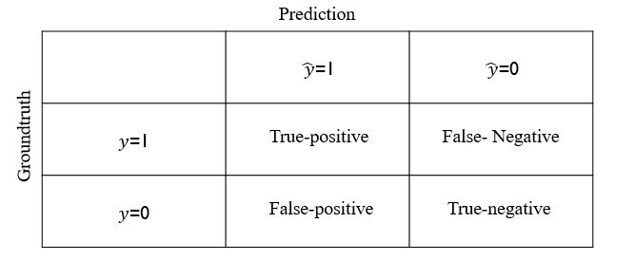

The above table is an example of a confusion matrix. If the prediction and ground truth are equal, then it is either True-positive or True negative based on the classification labels. If the prediction is not equal to the ground truth, then it is either False-positive or False-Negative based on the classification labels. From the table we are calculating the Accuracy, Precision and Recall.

We are also determining the ROC curve to evaluate the performance of the algorithm.

**Logistic Regression**

Logistic regression is a statistical method for analyzing a dataset in which there are one or more independent variables that determine an outcome. The outcome is measured with a dichotomous variable in which there are only two possible outcomes. The dependent variable is binary or dichotomous, i.e. it only contains data coded as 1 or 0. The binary logistic model is used to estimate the probability of a binary response based on one or more predictor variables [4].

The goal of logistic regression is to find the best fitting model to describe the relationship between the dichotomous characteristic of interest and a set of independent (predictor or explanatory) variables.

Logistic regression equation - Here p is the probability of presence of the characteristic of interest.

The logit transformation is defined as the logged odds:

Odds=p/(1-p)

and

Logit(p)=ln(p/(1-p))

## Major Results for Logistic Regression:

Confusion Matrix:

|  |  |  |  |
| --- | --- | --- | --- |
| Predictions | | | |
| Ground Truth |  | 1 | 0 |
| 1 | 162 | 11 |
| 0 | 10 | 27 |

Accuracy: 0.9000

Precision: 0.7105

Recall: 0.7297

ROC:

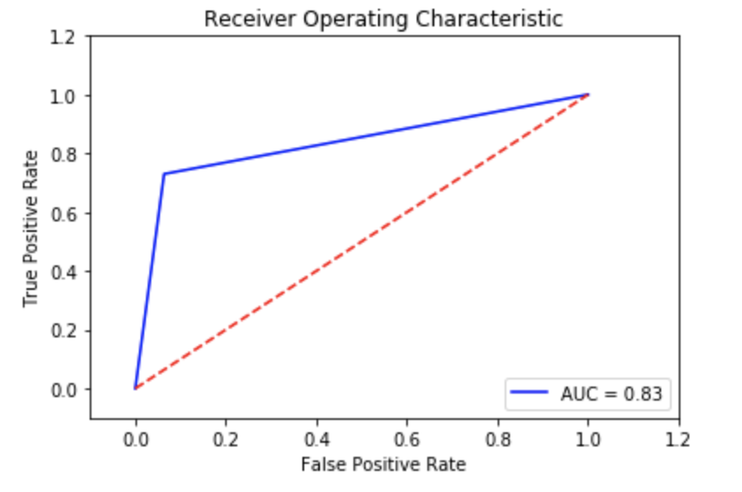

## Analysis

From the above results, it can be inferred that when we consider binary values as input the Logistic regression classifier has a good accuracy of 90.0% and the ROC curve gives an AUC of 0.83**.**

**The predictions are quite high, and this algorithm is very stable when we consider the dataset with more than one independent variable.**

**Support Vector Machines**

Support Vector Machine (SVM) is a supervised machine learning algorithm which can be used for both classification or regression challenges However, it is mostly used in classification problems. SVM is like a sharp knife – it works on smaller datasets, but on them, it can be much more stronger and powerful in building models.

In this algorithm, we plot each data item as a point in n-dimensional space (where n is number of features you have) with the value of each feature being the value of a coordinate.

## Major Results for SVM:

Confusion Matrix:

|  |  |  |  |
| --- | --- | --- | --- |
| Predictions | | | |
| Ground Truth |  | 1 | 0 |
| 1 | 166 | 7 |
| 0 | 10 | 27 |

Accuracy: 0.9190

Precision: 0.7941

Recall: 0.7297

ROC:

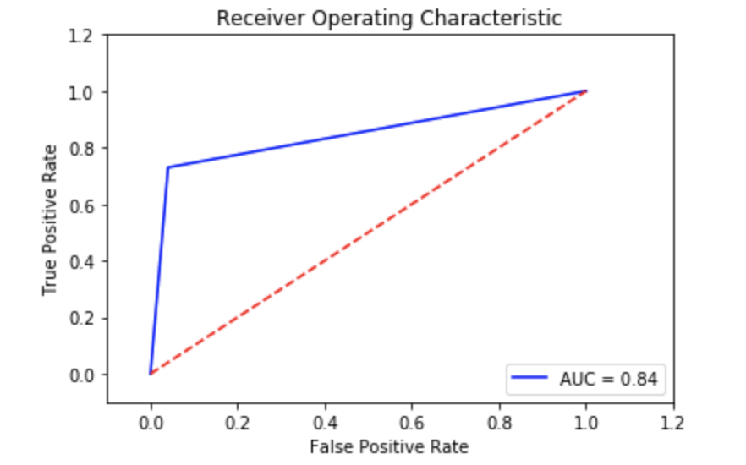

## Analysis:

The results of SVM algorithm, the accuracy of 91%, and the AUC is good, even though we get good accuracy, it seems not to be the best suited algorithm for our prediction.

**K-Nearest Neighbor Algorithm**

K-Nearest Neighbors algorithm (KNN) is a [non-parametric](https://en.wikipedia.org/wiki/Non-parametric_statistics) method used for classification and regression. However, it is more widely used in classification problems in the industry. In KNN classification, the input consists of the k closest training examples in the [feature space](https://en.wikipedia.org/wiki/Feature_space) and the output is a class membership. Here, majority vote of its neighbors classifies an object and being assigned to the class most common among its k nearest neighbors (k is a positive [integer](https://en.wikipedia.org/wiki/Integer), typically small). If k = 1, then the object is simply assigned to the class of that single nearest neighbor.

KNN is also a lazy algorithm, it does not use the training data points to do any generalization. In other words, there is no explicit training phase, or it is very minimal. This means the training phase is fast and lack of generalization means that KNN keeps all the training data. More exactly, all the training data is needed during the testing phase [3].

**KNN Algorithm:**

In the classification setting, the K-nearest neighbor algorithm essentially boils down to forming a majority vote between the K most similar instances to a given unseen observation. Similarity is defined according to a distance metric between two data points. A popular choice is the Euclidean distance given by



but other measures can be more suitable for a given setting and include the Manhattan, Chebyshev, and Hamming distance. More formally, given a positive integer K, an unseen observation x, and a similarity metric d, KNN classifier performs the following two steps:

1. It runs through the whole dataset computing d between x and each training observation. We’ll call the K points in the training data that are closest to x the set A. Note that K is usually odd to prevent tie situations.
2. It then estimates the conditional probability for each class i.e., the fraction of points in AA with that given class label. (Note I(x) is the indicator function which evaluates to 1 when the argument x is true and 0 otherwise)

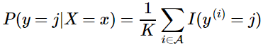

Finally, our input x gets assigned to the class with the largest probability.

## Major Results for KNN:

Confusion Matrix:

|  |  |  |  |
| --- | --- | --- | --- |
| Predictions | | | |
| Ground Truth |  | 1 | 0 |
| 1 | 169 | 4 |
| 0 | 18 | 19 |

Accuracy: 0.8952

Precision: 0.8260

Recall: 0.5135

ROC:

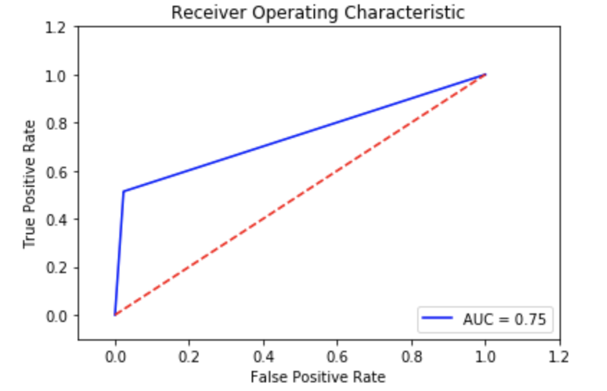

## Analysis

KNN algorithm is one of the simplest classification algorithm. Even with such simplicity, it can give highly competitive results. The only difference KNN classifier has from regression is the methodology, which uses the averages of nearest neighbors rather than voting from nearest neighbors.

Based on the above results, it can be inferred that the K-Nearest Neighbor classifier at k = 5 has a good accuracy of 89.5% and the ROC curve gives an AUC of 0.75.

**Naïve Bayes Algorithm**

Naïve Bayes Algorithm is a classification technique based on [Bayes’ Theorem](https://en.wikipedia.org/wiki/Bayes%27_theorem) with an assumption of independence among predictors. In simple terms, a Naive Bayes classifier assumes that the presence of a feature in a class is unrelated to the presence of any other feature. Naive Bayes model is easy to build and particularly useful for very large data sets. Along with simplicity, Naive Bayes is known to outperform even highly sophisticated classification methods.

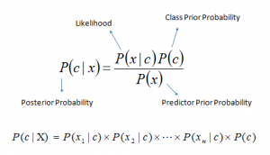

Above,

* P(c|x) is the posterior probability of class (c, target) given predictor (x, attributes).
* P(c) is the prior probability of class.
* P(x|c) is the likelihood which is the probability of predictor given class.
* P(x) is the prior probability of predictor.

The working of Naïve Bayes algorithm can be explained in 3 steps

1. Converting the dataset into frequency model.
2. Create a likelihood table by finding the probabilities.
3. Use Naive Bayesian equation to calculate the posterior probability for each class. The class with the highest posterior probability is the outcome of prediction.

## Major Results for Naïve Bayes:

Confusion Matrix:

|  |  |  |  |
| --- | --- | --- | --- |
| Predictions | | | |
| Ground Truth |  | 1 | 0 |
| 1 | 147 | 26 |
| 0 | 8 | 29 |

Accuracy: 0.8380

Precision: 0.5272

Recall: 0.7837

ROC:

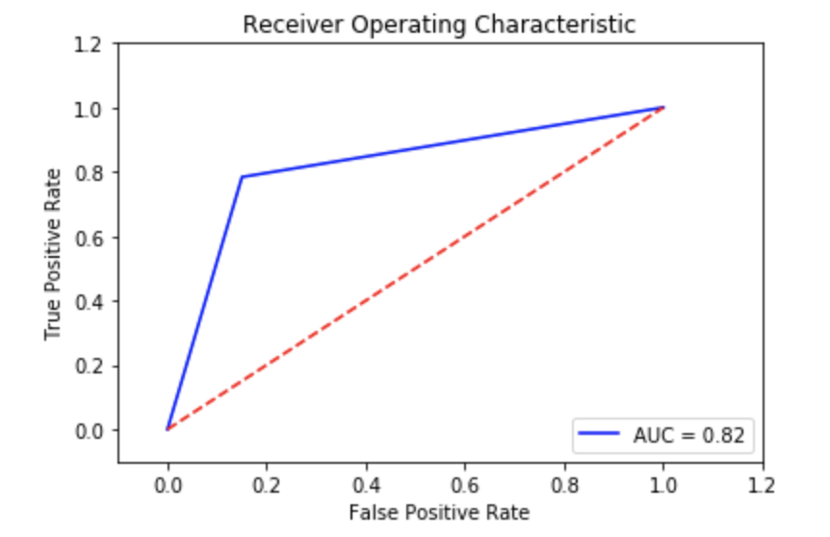

## Analysis

The accuracy for Naive Bayes Classifier is 83.8%. ROC is good but in comparison to other models which are under the scope of our study, NBC seems to an underperforming model for our dataset. AUC is 0.82 which is a decent figure as well.

**Adaboost Algorithm**

AdaBoost stands for Adaptive Boosting which is a machine learning meta-algorithm formulated by Yoav Freund and Robert Schapire. This algorithm is used in conjunction with other types of learning algorithms to improve performance [7].

A family of weak learner algorithms are used together to form strong-learners. To find a weak rule, we apply base learning (ML) algorithms with a different distribution. Each time a base learning algorithm is applied, it generates a new weak prediction rule. This is an iterative process. After many iterations, the boosting algorithm combines these weak rules into a single strong prediction rule.

The disadvantage of Adaboost is that it can be susceptible to noisy data and outliers while being prone to overfitting.

## Major Results for Adaboost:

Confusion Matrix:

|  |  |  |  |
| --- | --- | --- | --- |
| Predictions | | | |
| Ground Truth |  | 1 | 0 |
| 1 | 172 | 1 |
| 0 | 0 | 37 |

Accuracy: 0.9952

Precision: 0.9736

Recall: 1.0

ROC:

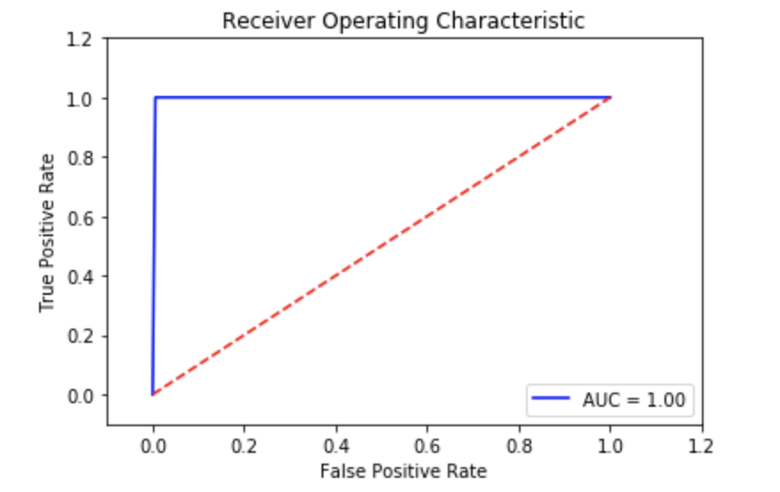

## Analysis

The Adaboost algorithm is used in conjunction with Decision tree algorithm with maximum depth being equal to 2.

Decision trees are used with Adaboost as they are non-linear while being fast to train. They are also fast to classify and thus can be used in large numbers.

From the above results, it can be inferred that the Adaboost has a very high accuracy of 99.5%. The ROC curve gives an AUC of 1 which is a perfect score indicating a perfect test.

**Visualization**

We have also performed visualizations on the data.

## Visualization based on Ratings.

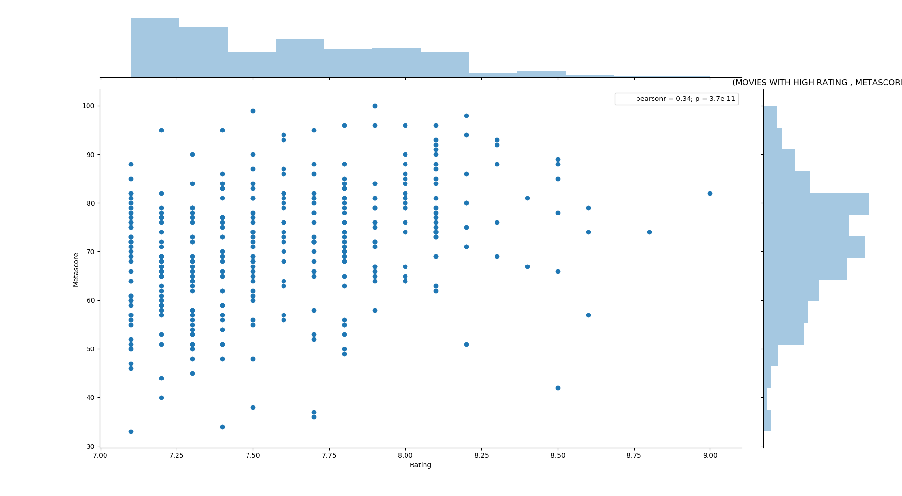

Fig 1. Movie with high rating & metascore

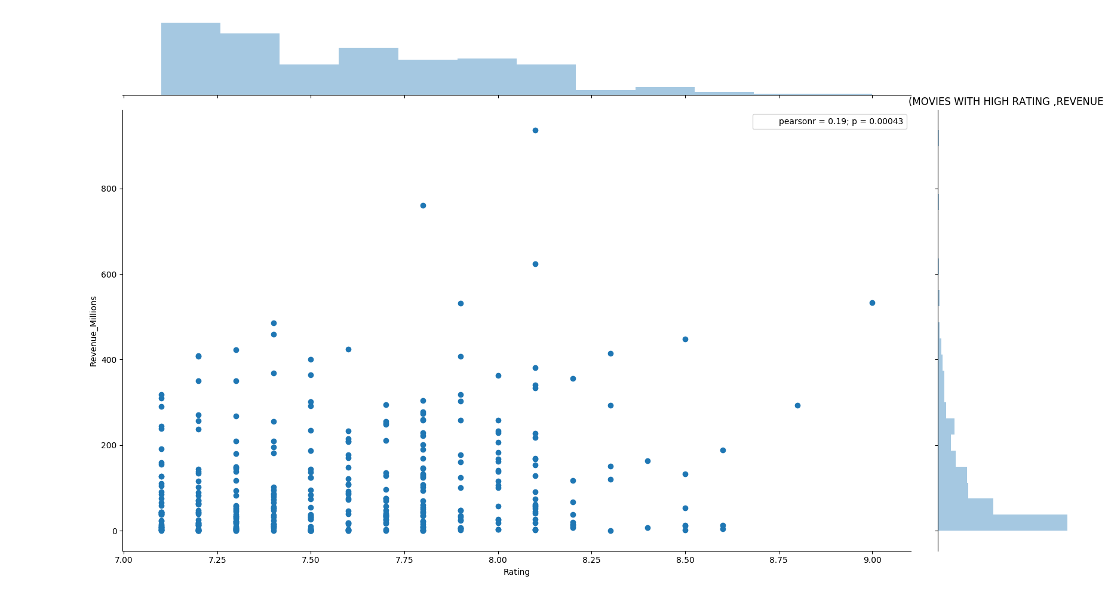

Fig 2. Movies with high rating & revenue

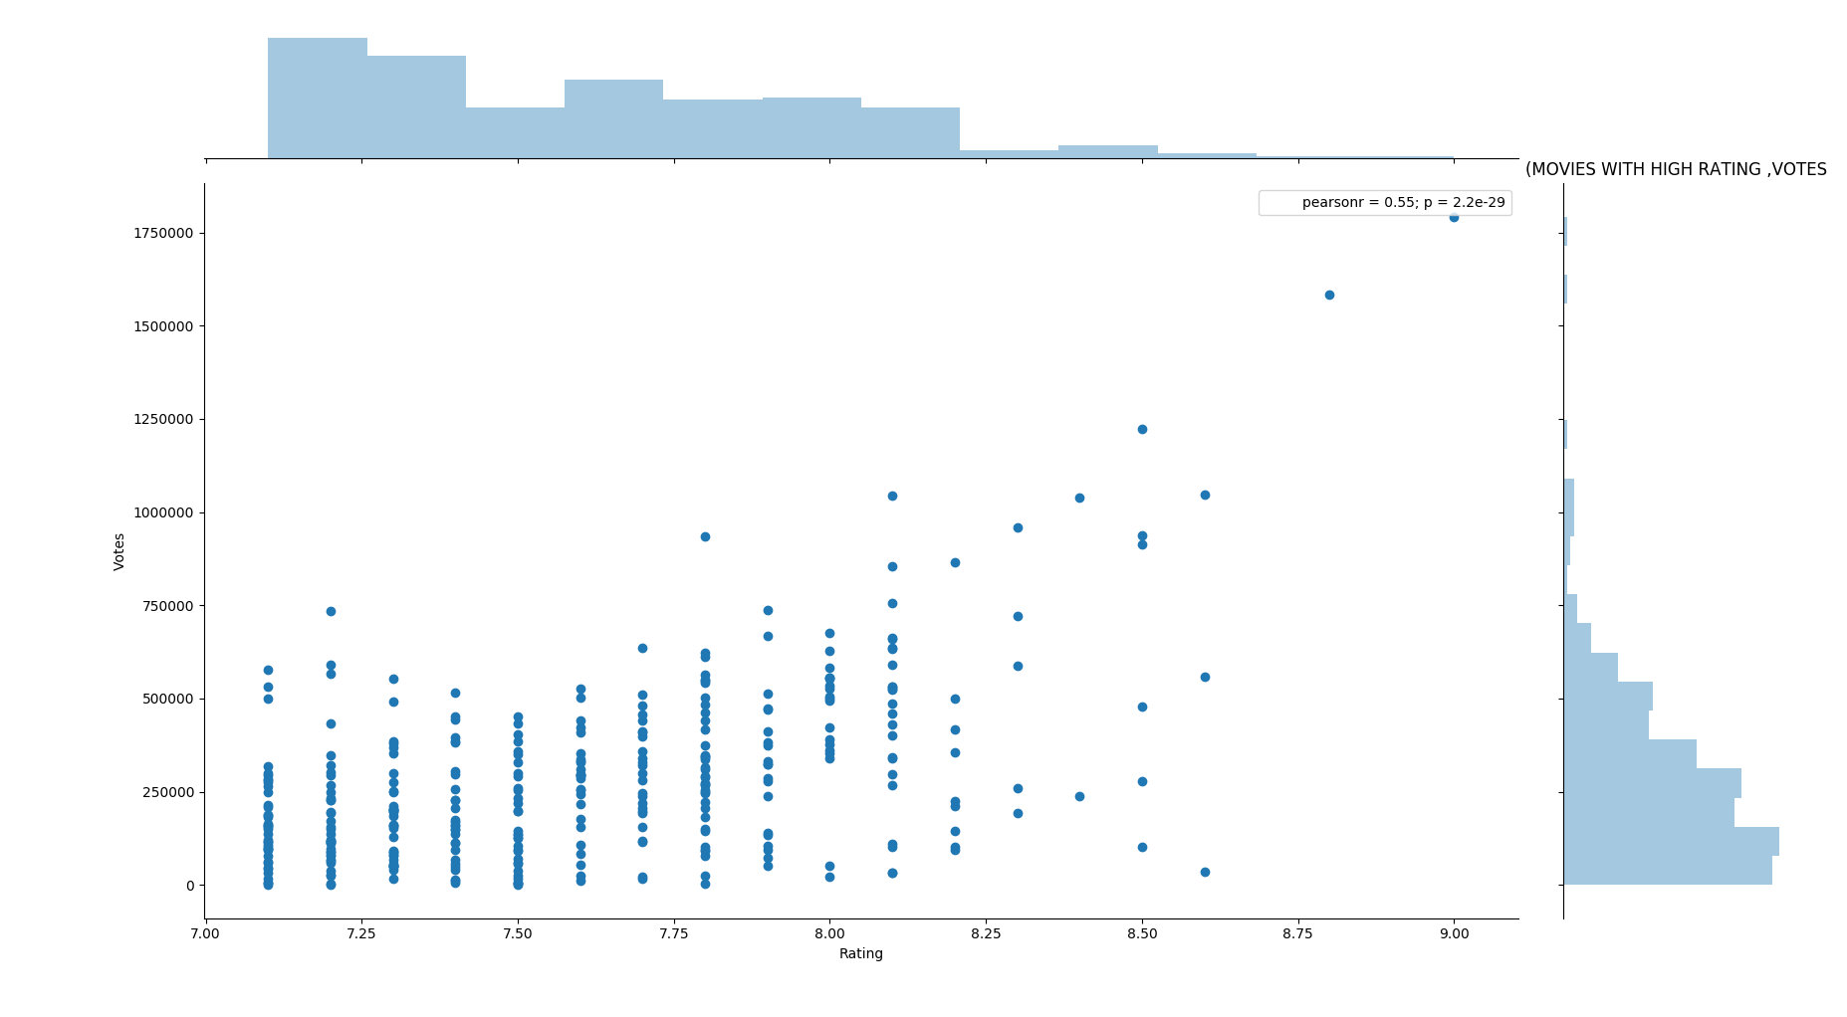

Fig 3. Movies with High rating & Votes

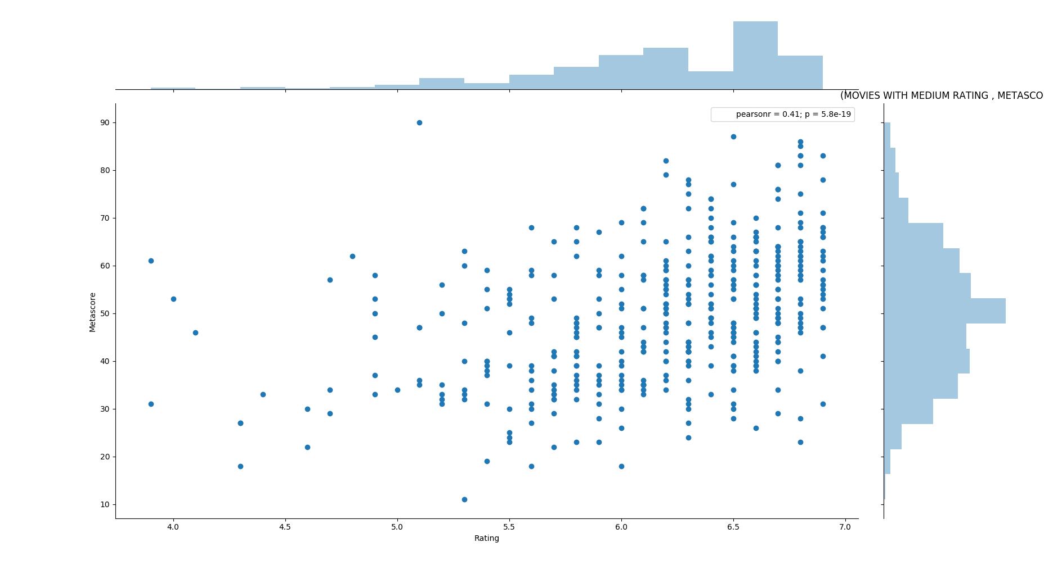

Fig 4. Movies with Medium rating & metascore

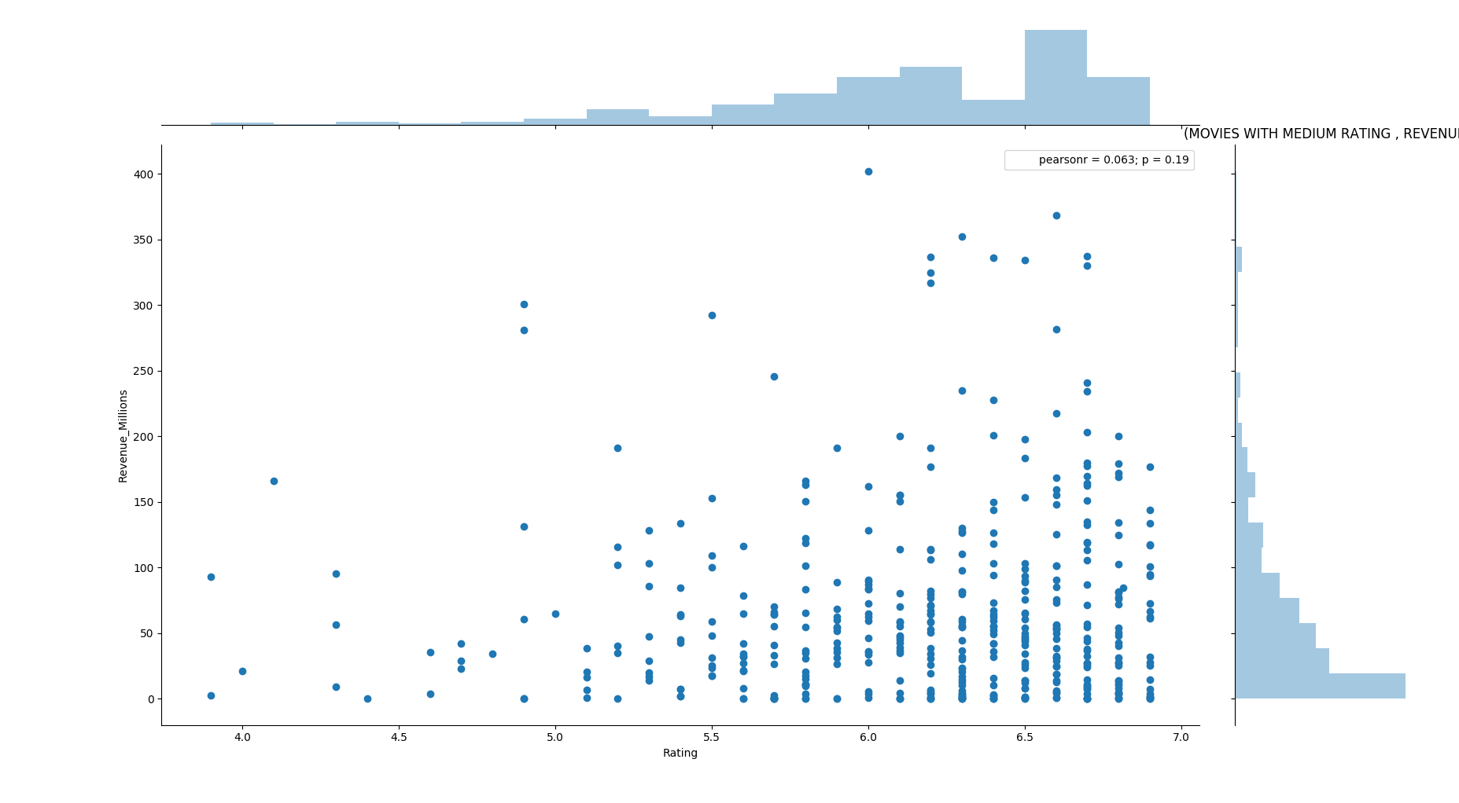

Fig 5. Movies with Medium rating & revenue

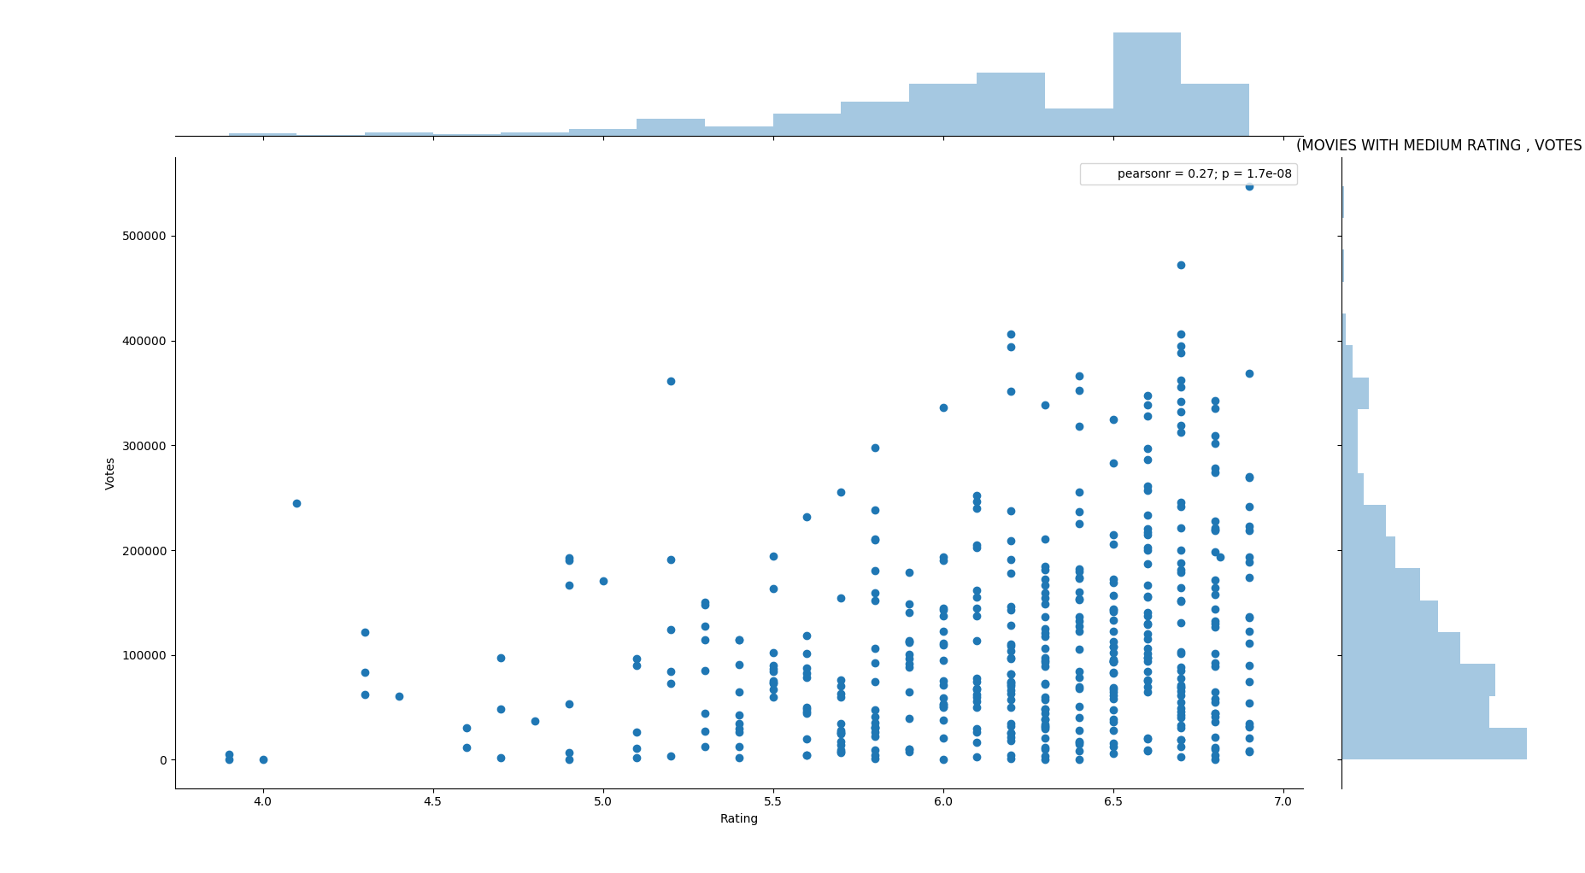

Fig 6. Movies with medium rating & votes

* 1. *Top Ten Directors*

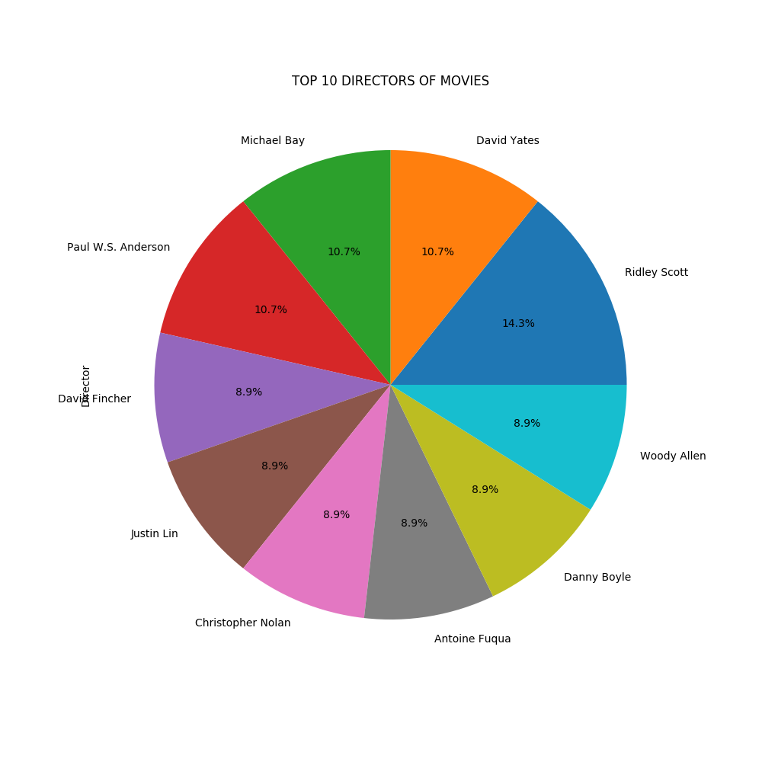

* 1. *Rating V/S Year*

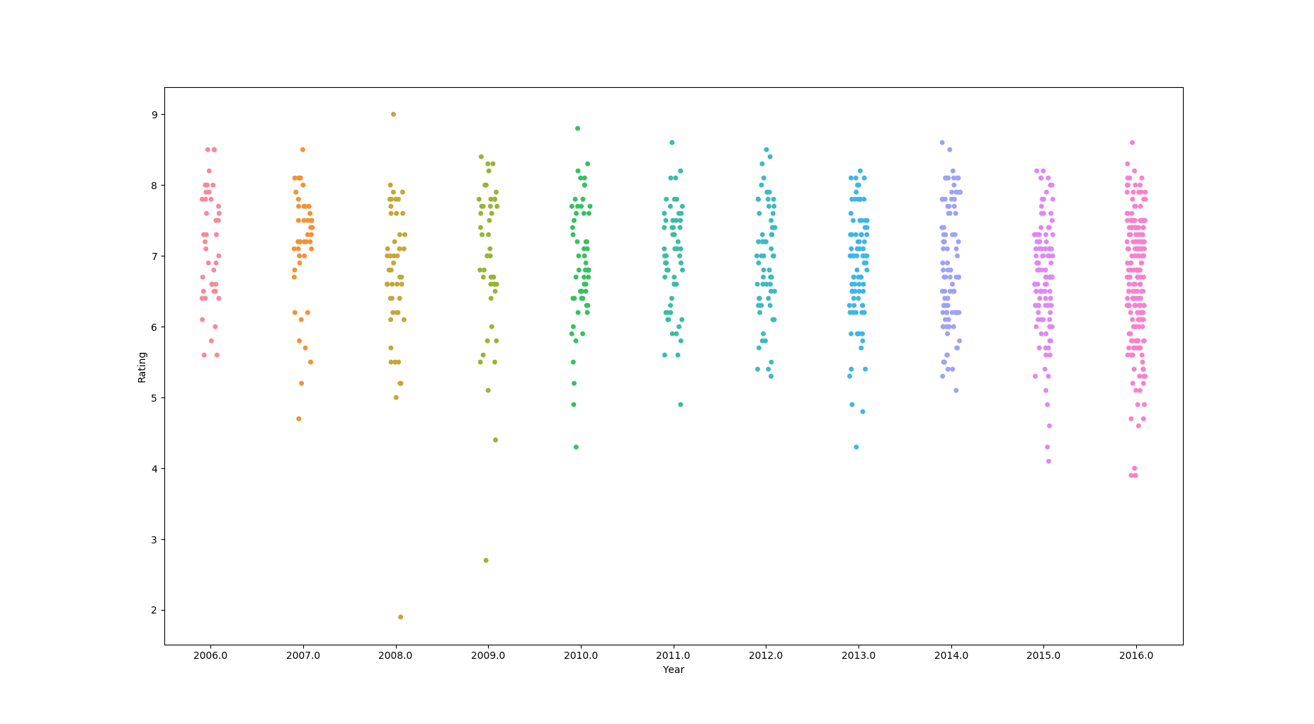

# Conclusion AND FUTURE WORKS

|  |  |  |  |  |  |
| --- | --- | --- | --- | --- | --- |
| Algorithms | Accuracy | Precision | Recall |  | AUC |
| Logistic Regression | 0.9000 | 0.7105 | 0.7297 |  | 0.8300 |
| Support Vector Machines | 0.9190 | 0.7941 | 0.7297 |  | 0.8400 |
| K-Nearest Neighbor Algorithm | 0.8309 | 0.5272 | 0.7837 |  | 0.8200 |
| Naïve Bayes Algorithm | 0.5333 | 0.2706 | 0.9729 |  | 0.7100 |
| Adaboost Algorithm | 0.9952 | 0.9736 | 1.0000 |  | 1.0000 |

After building the models we found out that the success percentage for all models were nearly the same however the Adaboost with Decision Tree model had the highest accuracy in our case for predicting the movies success. A larger training set is the key to improving the performance of the model. We need to consider additional features such as geographic location, age of viewers and voters, current trends, news analysis, movie plot analysis and social networks data analysis could be done and the information thus obtained could be added to the training set. We can also use Google trends result to improve the result.

References

[1] Darin Im, Minh Thao, Dang Nguyen, Predicting Movie Success in the U.S. market, Dept.Elect.Eng, Stanford Univ., California, December,2011

[2] Jiawei Han, Micheline Kamber, Jian Pei, Data Mining Concepts and Techniques, 3rd ed.MA:Elsevier, 2011, pp. 83-117

[3] Richard O. Duda, Peter E. Hart, David G. Stork, Pattern Classiﬁcation, 2nd. NewYork: Wiley, 1973

[4] Cohen, J., Cohen P., West, S.G., & Aiken, L.S. (2003). Applied multiple regression correlation analysis for the behavioral sciences. (2nd ed.) Hillsdale, NJ: Lawrence Erlbaum Associates

[5] Christopher M. Bishop (2006), Pattern Recognition and Machine Learn-ing, Springer, p. 205.

[6] The International Movie Database (IMDb): <https://www.kaggle.com/PromptCloudHQ/imdb-data>

[7] Freund, Y.: An adaptive version of the boost by majority algorithm. Machine Learning 43(3), 293–318 (2001)

[8] Haiyi Zhang, Di Li Jodrey School of Computer Science Acadia University, Canada, Naïve Bayes Text Classifier (2007)